# **Python Rename File and Directory using os.rename()**

When working with servers you mostly get terminal to perform different functions. Some times you need to write different script that require you to rename a file or directory. Let’s take a look at how to rename a file and directory using Python “os” library.

There is a built-in function os.rename(src, dest) that take two arguments source location of the file or directory and destination location of the file or directory.

## Renaming File

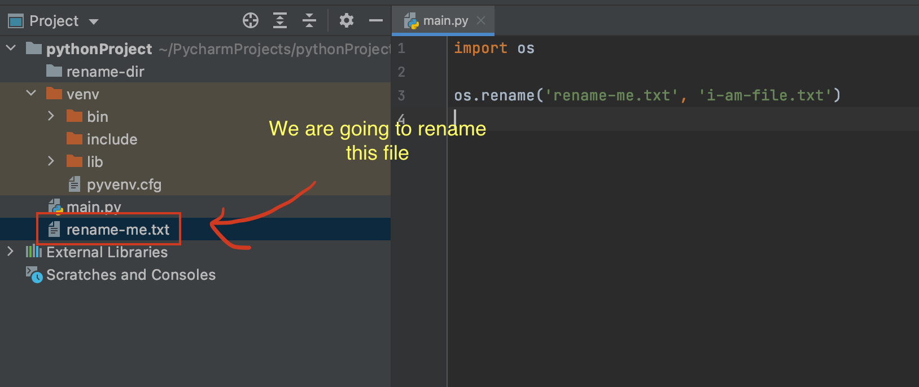

Let’s run the following code.

|  |
| --- |
| import os  os.rename('rename-me.txt', 'i-am-file.txt') |

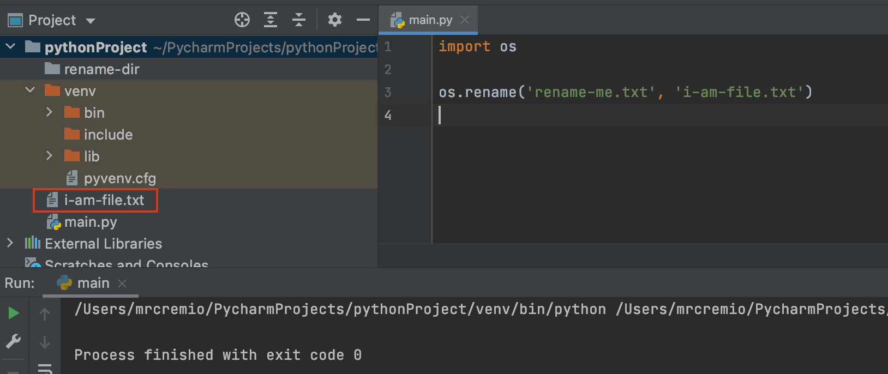

## Renaming Directory

Now let’s rename the directory. Renaming directory is same as renaming file.

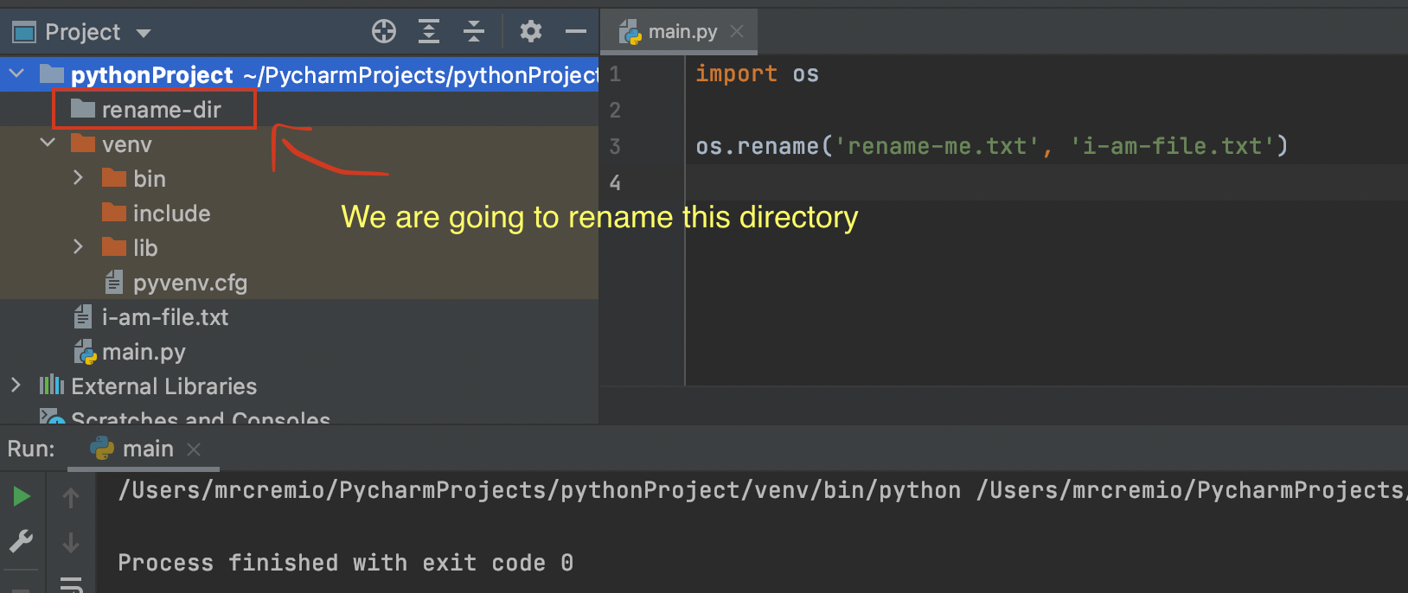

Let’s execute the following code to rename the directory.

|  |
| --- |
| import os  os.rename('rename-dir', 'dir-renamed') |

